Information on OOTS the Trio booked and the Music

Event Date: June 20th 2018

Orchestra of the Swan

Orchestra of the Swan has its home in Shakespeare’s Stratford-upon-Avon and celebrated its 21st Anniversary last season (2016/2017). OOTS is also Associate Orchestra at Town Hall Birmingham with regular concert series at Number 8 Pershore, Worcester Cathedral and Malvern Theatres.

The orchestra gives over 45 concerts annually and is increasing its overseas touring. In 2014 the orchestra undertook its first highly successful tour to China. In 2016 OOTS performed in the Istanbul International Festival; during 2016/17 we toured to Mexico and performed our concert debut in New York (Carnegie Hall). OOTS has also toured the UK with groups such as Steve Harley & Cockney Rebel and James, with sell-out performances at London’s Albert Hall.
Recordings have been Gramophone Choice, CD of the Week on Classic Fm (UK) and Washington Public Radio, and live concert recordings are frequently broadcast on USA Performance Today, in Canada and Australia.
The orchestra’s extensive discography includes repertoire by Barber, Bax, Berlioz, Brahms, Copland, Debussy, Elgar, Finzi, Ireland, Mahler, Mendelssohn, Mozart, Schumann, Strauss, Vaughan Williams and the world premiere recording of the complete symphonies by Hans Gál. The latter received outstanding critical acclaim and was featured on BBC Radio 3 ‘Composer of the Week’. Most recently Mendelssohn’s D minor Violin Concerto with Tamsin Waley-Cohen was BBC Music Magazine’s ‘Recommended Recording’.

The Music
- Lark Ascending
- Horn concerto
- Hall of the Mountain King
These pieces feature the instruments from the OOTS trio.

The day will include:
- Performance by OOTS player Naomi Rump, Rebecca Eldridge and Craig MacDonald (info about them below), intro to them, their careers, and what their instruments can do
- fun and interactive instrumental workshops led by OOTS players to help players brush up their technique
- improvisation workshop - exploring your instrument and what it can do
- CPD opportunity for teachers to share and develop own practice
- collaborative performance opportunity
- mini sharing concert to parents
The Players

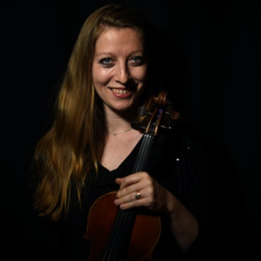 | Naomi Rump began the violin at the tender age of six, studying with Kathryn Hardman and Christopher Hirons. She graduated from Cambridge University with a First in English, and launched herself into the itinerant life of the freelance violinist. She now lives in Bristol, but finds her work leading much further afield: the last twelve months allowed her to take in icebergs in Greenland, midnight sun in St.Petersburg and Norwegian fjords, alongside the more prosaic traffic-jams of the M25.
Naomi frequently plays for the Pavão Quartet: recent highlights have included the Elgar piano quintet with John Lill; a long-running ‘Paul Robeson’ collaboration with Sir Willard White; a recording for the Classic FM label with guitarist Craig Ogden; and a recording, for Decca, of composer Eric Whitacre’s choral music, for the album ‘Light and Gold’. The last two discs topped the classical music charts in the UK and USA. Other recordings include work with Hayley Westenra, John Barrowman, The Villagers and the music for Rick Stein’s television series. She has played the viola with Ronnie Scott’s All Stars.
Naomi holds seats in both the Bristol Ensemble and the Orchestra of the Swan, and has recorded with Welsh National Opera. She also makes occasional forays into the commercial market, filming for Sky television and recording with Bristol Ensemble for the BBC’s natural history department. She works as an animateur in special needs schools, particularly enjoying projects with autistic children. She is currently the recipient of the Sir Charles Makerras Fellowship at the Royal Welsh College of Music and Drama.

Craig MacDonald is a french horn player originally from Elgin in Scotland. Craig has been living in Cardiff for 6 years and has been working as freelance musician since he finished his studies in 2009.  After finishing school, Craig won a place at the Royal Conservatoire of Scotland (Royal Scottish Academy of Music and Drama as it was known then) in 2004, and studied with David Flack and Hugh Potts for four years. He graduated with a BMus in performance. | 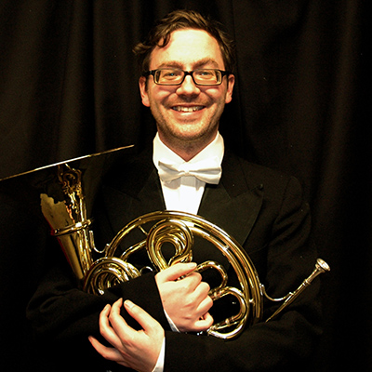
He then won a Leverhulme Arts Scholarship to study for a MMus in Orchestral performance at the Guildhall School of Music and Drama. He studied with Hugh Seenan, Jeff Bryant and Richard Bissil, and graduated with a Masters degree in 2009.
As well as Craig’s recent appointment as 2nd Horn with the Orchestra of the Swan, Craig has a busy freelance and teaching career. As a freelance musician, Craig has worked with many orchestras throughout the UK and abroad. These include: the Royal Philharmonic Orchestra, BBC National Orchestra of Wales (including a trial for 2nd horn), Welsh National Opera, Royal Scottish National Orchestra, Scottish Chamber Orchestra, Royal Ballet Sinfonia, English National Ballet, Manchester Camerata, RTE National Symphony Orchestra and the Symphony Orchestra of India.

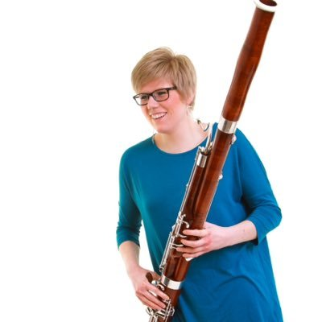 | Rebecca Eldridge is a bassoonist and in 2012 won a scholarship to study on the MMus orchestral course at the Guildhall School of Music and Drama with Graham Sheen, Helen Simons, Gordon Laing and Martin Field. Prior to this, Rebecca graduated with first class honours from the Royal Welsh College of Music and Drama, studying with Meyrick Alexander, Martin Bowen, Steve Marsden and contrabassoon with Chris Vale.
During her studies, Rebecca won the Three Choirs Festival Ensemble Prize, Howarth Double Reed prize, Royal Welsh College of Music and Drama’s Concerto prize, June Emerson Wind Ensemble Launchpad prize and the Abergavenny Eisteddfod.
Rebecca has worked with various orchestras including the Orchestra of Welsh National Opera, Oxford Philharmonic Orchestra, Up North Session Orchestra, Orchestra of the Swan, Royal Shakespeare Company and Orpheus Sinfonia. She was also contrabassoonist with the Young Musician’s Symphony Orchestra and has participated in side-by-side schemes with the Philharmonia Orchestra, London Symphony Orchestra and the BBC National Orchestra of Wales. Rebecca was Co-principal Bassoon with Southbank Sinfonia 2017.
As a soloist Rebecca has performed concertos with the Royal Welsh College of Music and Drama’s Chamber Orchestra, Chandos Symphony Orchestra, Sinfonia of Birmingham, Leamington Chamber Orchestra and Inkberrow Sinfonia. Also a keen chamber musician Rebecca is a founding member of the Aquilon Ensemble. This has led to performances on BBC Radio 3, UK and European tours and coaching from Andrew Marriner, Francois Leleux, Sarah Burnett and Neil Black.

